Using Visual Studio 2008

# First Run

When Visual Studio is first run, the following dialog appears. Select “Visual C++ Development Settings” then click on “Start Visual Studio”:

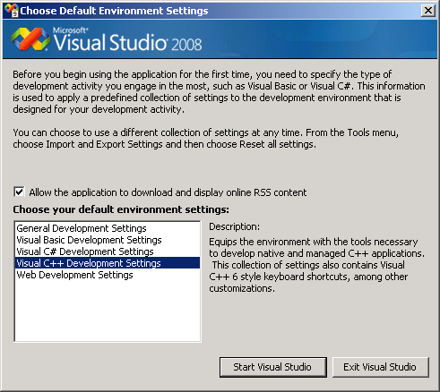

Visual Studio will then take a few minutes to create your settings:

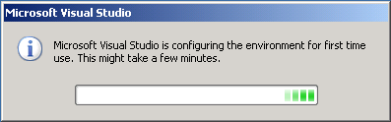

# Configuration Step: Displaying Build Errors by Default

If Visual Studio 2008 encounters build errors, it will not automatically display them by default. We can (and should) change this as follows. First click “Tools->Options”: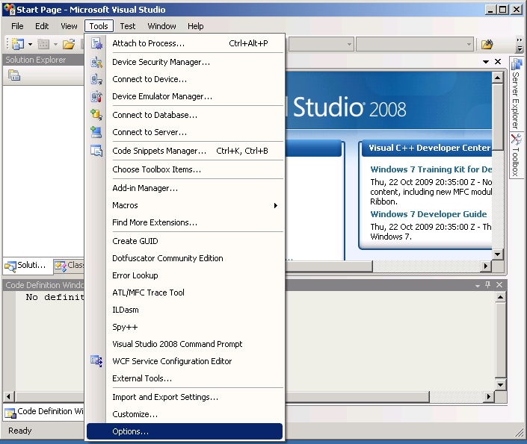

In “Projects and Solutions->General”, make sure “Always show Error List if build finishes with errors” is checked, then click on “OK”.

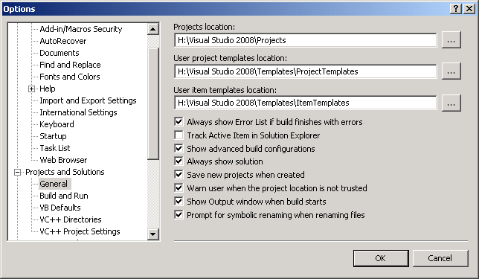

# Creating a C Project in Visual Studio 2008

1. Select “File->New->Project”:

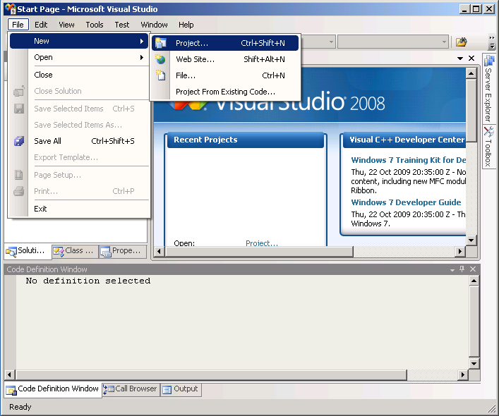

1. Select “Win32” in the left pane, and then “Win32 Console Application” in the right pane. Enter a project name and click on “OK”: (please ensure the “Location” begins: “H:\Visual Studio 2008\Projects”)

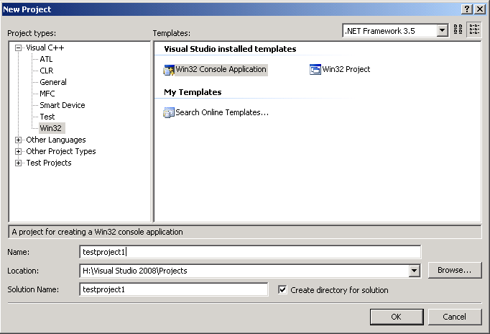

1. Select “Application Settings”, make sure that “Empty project” is checked. Then click on finish:

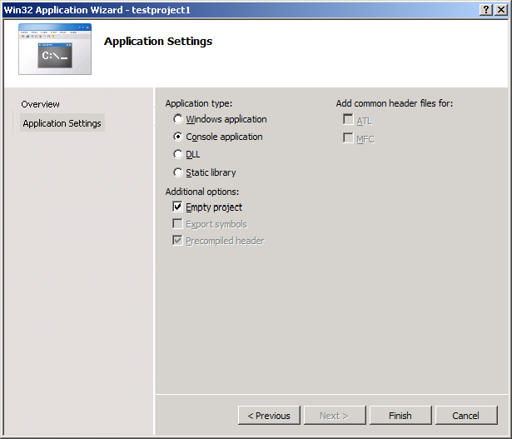

1. Now we need to add a C source file to our project. In the solution explorer, right click on “Source Files” and select “Add->New Item”:

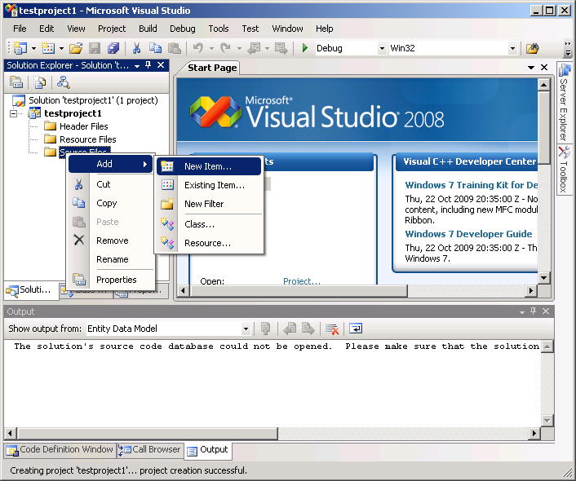

1. Select “Code” in the left hand pane and “C++ file” from the right hand pane. Then enter a filename. **It must have a “.c” extension!** Then click on “Add”.

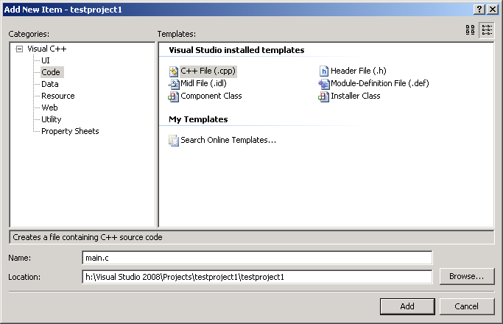

1. Now enter the following C code into “main.c”:

#include <stdio.h>

int main()

{

printf("Hello World!\n");

return 0;

}

1. Press [CTRL]+[F5] (at the same time) to run the project, you will get the following dialog box. Click on “Yes” to proceed:

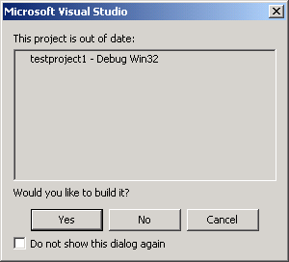

1. Hopefully, your program will then compile and run:

